Blue Team Shooting Sports Action Pistol October 28th, 2025
COURSE DESIGNER: Ike Starnes
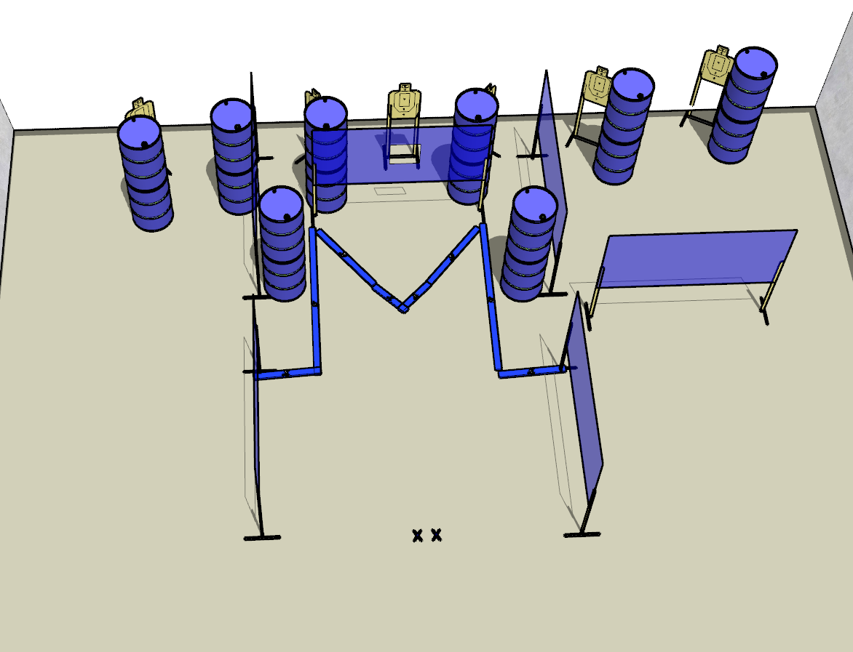

Written Stage Briefing:

Stage 3 - Isn't three the perfect number? - is a 18-round, 90 point, Comstock Course. There are 6 cardboard targets and some noshoots. The best 3 hits per cardboard target will be scored.
Handgun start position Both feet on Xs with wrists below belt. The handgun is loaded and holstered.
PCC start position Both feet on Xs. PCC is loaded with stock touching belt.
On the audible start signal, engage all targets from within the shooting area.

